
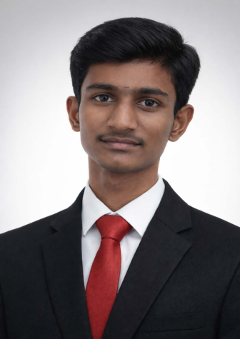
RESUME
Lakshmiajay K
101/1,T.pudhur,
Anekollu , denkanikottai,
Tamilnadu -635113.
9688003847
lakshmiajay252in439@gmail.com
BE-COMPUTER SCIENCE AND ENGINEERING
CGPA : 7.54
No Active Backlogs
—
Career Objective |  | Dedicated Computer Science student with strong foundational knowledge in  programming and problem-solving. Seeking an opportunity to enhance
technical skills and contribute effectively in a professional environment.
ㅡ
Technical Skills
★Java
★SQL
★DataAnalytics
★Python (basics)
★HTML (basics)
—
Strengths
❖ Quick Learner
❖ Analytical Thinking
❖ Team Collaboration
❖ Effective Communication
—
Education
BE-COMPUTER SCIENCE AND ENGINEERING.

—
Academic Work Seminar presentation - cloud computing,
ㅡ
Social media
LinkedIn
https://www.linkedin.com/in/lakshmiajay252in439
GitHub
https://github.com/Lakshmiajay-k
LeetCode
https://leetcode.com/u/lakshmiajay_k/
—
Academy | Shreenivasa Engineering College ,  September 2024-2028(UG),
B. Pallipatti, Bommidi, Papireddipatti Taluk,
Tamil Nadu ,635301.
ㅡ
Certifcations | ➢ | DataAnalytics internship
➢ Machinelearning internship
➢ Artifcial intelligence internship
➢ DataAnalytics masterclass
➢ Intermediate in Java
ㅡ
Personal details
Languages : Tamil ,English.
DOB : 04-07-2007
—
Declaration I hereby declare that the above information is true to the best of my
knowledge.
—
Place: B.pallipatti. Signature
Date: ____________

